Waimea Plains Railway - Newsletter,
December 2023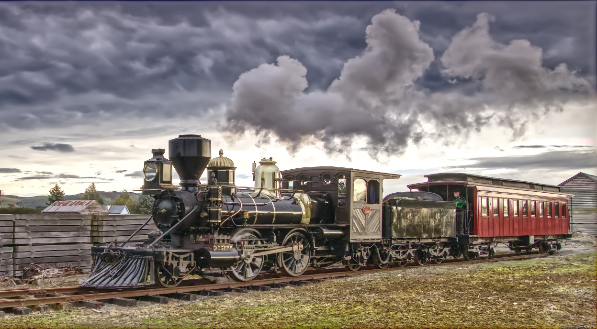
New Season Running Days.
With the first 3 scheduled running/operating weekends completed with pleasing results financially, mechanically and fortunately with good weather, made for a pleasant start to this new seasons operating programme. Our new schedule has been in the main, centred around the Pounamu Rail Tours programme, thus capturing the opportunity to display our quite unique Loco K92 to a broader base of off shore Railway enthusiasts.
The dates for the first half of 2024 Running Days are as follows: January 13th & 14th, February 3rd & 4th and 24th & 25th (Fly-In Steam Festival), March 16th & 17th and 30th & 31st, April 20th & 21st and May 11th & 12th.
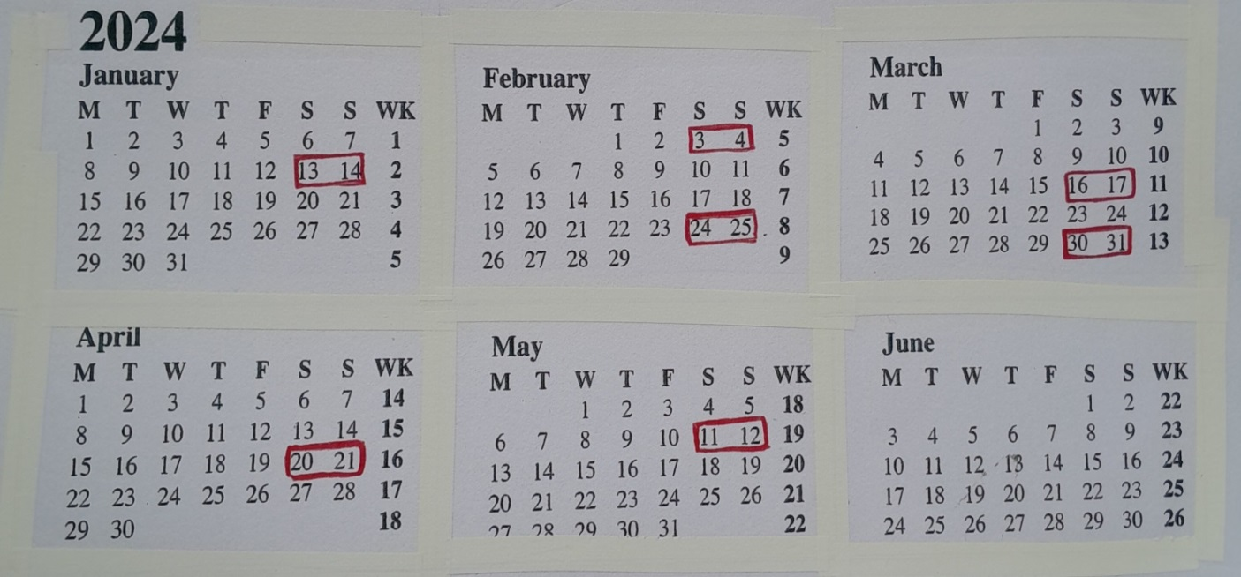
The Loco will be prepared for Annual survey over the winter period and all being well we anticipate operating again in October 2024.

Land Acquisition.
As agreed some 20 years ago, with the adjoining land owners, Val and Geoff Horrell, that on the occasion they were to relinquish the land to the west of the existing Railway Yard, they would make sure that the Railway Trust would get first refusal over the Eastern most area that was part of the original Rail Corridor for Waimea Plains Railway. The twenty-three year old arrangement was necessary, for it would guarantee the W.P.R Trust proposed Yard Plan could mirror the original Railway Line and also the original loop which converged with the Main line within that area of land. Now that the W.P.R. Trust owns that land, our Plan can become a reality. Thank you to the Horrell Family for honouring, the long term understanding which was agreed then, by only a handshake.
This acquisition may also offer the Trust a second alternative to entering the Airfield with the main railway line proposal.
KiwiRail and Rail acquisition.
Over the last two months our Trust has finally come to an arrangement with KiwiRail for the purchase of rail, over a period of time, sufficient to complete the designed length of Rail Track around the Airfield, i.e. approx. some 5000m of rail. The Trust wishes to acknowledge our gratitude to Zac Pritchard of Christchurch and Michael Buckley, Zac for his efforts in negotiating the arrangements with KiwiRail just prior to his retirement. Michael now takes up Zac’s responsibilities.
Gulley Building.
With the primary structure of the planned replication of the original Gulley building from Hillside, Dunedin, now completed and the total area, some 900+m2. The next priority is to utilise the “space” in the best way possible until the Trust is in a position to finance the outer cladding etc. to complete the project. With some immediate attention to conveying rain water from the large roof to temporary storage or initially to a nearby drain and the laying of a relatively short length of railway track, we will at last be able to utilise the area to cover all the currently acquired Heritage Rolling Stock the Trust has committed to preserving. i.e. Two Addington Cars of 1883 circa, A194, A196, and one “B” car B72, 3 Cars of the 1893 era, A294, A463, A130 and Guard Van F111, some seven period wagons, one Steam and one Coal Crane and our Locomotive.
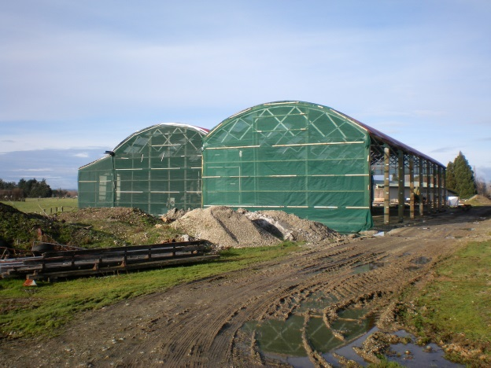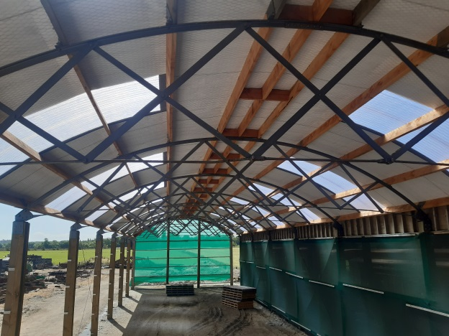
Infrastructure:
From the outset of establishing the Waimea Plains Railway Trust, the configuration of the Railway Yard system defined by Trustee Robert Storm has remained virtually unchanged from the original concept, i.e. “Two incorporate at least one of every “Rail Structure” that was commonplace in NZ from the 1880’s through to the early 1900’s a little adjustment has been necessary from time to time, but the principal objective remains steadfast to this end. In an endeavour to solve a dilemma the Trust has on the one hand with the Loco parked at the roadside the touring public do stop and photograph her regularly whereas, when it is shifted undercover, many tourists just pass, and everyone loses the opportunity to earn a little revenue. Hence another Robert tweak to the Rail system, tentatively an additional track running parallel to the original main track could be established ending at the roadside, with an adaption to existing veranda trusses to incorporate the original cast Iron panels from the old Invercargill station and this track being of 1860s-80’s Bull Nose rail in original chairs, with the Loco under the Northern wall of the structure, resulting in probably the best public statement that could be made to demonstrate the Trusts existence.
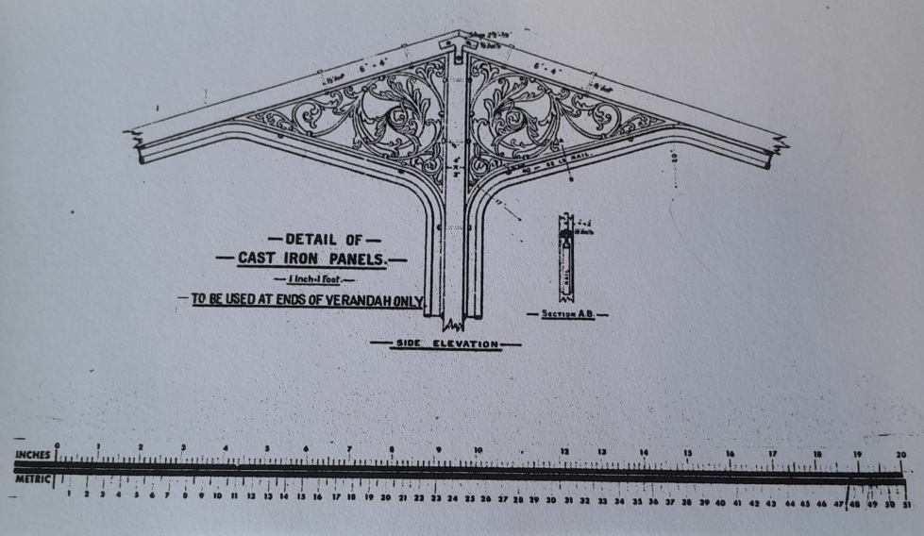
On the other hand we have still to establish quite a lot of railway track in the yard as originally planned and it will require a dedicated working Bee to complete the next most useful section of Track. In an endeavour to prepare for this track work I would like to ask our supporters/helpers that if they could spare a day over the holiday period to assist with preparation type work, to please indicate by text message or call Maeva’s phone 0272297945.
Finally I would like to thank all those people who throughout the year, helped contribute to further establishing the Waimea Plains Railway at Mandeville as an intriguing Operational Heritage Railway and wish you all a Merry Christmas and a prosperous New Year.
Colin Smith. Chairman.


